**MUZIKA**

**A MUSIC PLAYER USING PYTHON**

**A**

**Project Report**

**Submitted**

**In Department of Computer Science & Engineering**

# Bachelor of Technology



**Guided by:**  **Submitted By**

**Ms. Jaspreet Kaur** YATENDRA TYAGI

HARSH PANWAR

PRIYANKA THAKUR

# Department of Computer Science & Engineering

**PUNJAB TECHNICAL UNIVERSITY**

**Main Campus Jalandhar**

# DECLARATION BY THE CANDIDATE

We the undersigned solemnly declare that the project report MUSIC PLAYER USING PYTHON is based on our own work carried out during the course of our study under the supervision of Ms. Jaspreet Kaur. I further certify that :

1. The work contained in the report is original and has been done by us under the general supervision of my supervisor.
2. The work has not been submitted to any other Institution for any other degree/diploma/certificate in this university or any other University of India or abroad.
3. We have followed the guidelines provided by the university in writing the report.
4. Whenever we have used materials (data, theoretical analysis, and text) from other sources, we have given due credit to them in the text of the report and giving their details in the references.

YATENDRA TYAGI(1916717) HARSH PANWAR(1916709)

PRIYANKA THAKUR(1916714)

# ABSTRACT

This is a Project Report on “MUZIKA - A Music Player Using Python”. During the making or Development of the project we explored new ideas and libraries in python for implementing GUI based Application.

The Project is the output of our planning, schedule, programming skills and the hard work, and this report reflects our steps taken at various levels of programming skill ,planning and schedule.

We have learnt a lot during this project in our coding skills and deep concept related to these kind of projects .

Our project is “MUZIKA - A MUSIC PLAYER USING PYTHON”. This is a python based application which enables people to play their local songs.

# TABLE OF CONTENTS

|  |  |  |
| --- | --- | --- |
| SR. NO | CHAPTER NAME | PAGE NO. |
| 01 | INTRODUCTION | 7 |
| 02 | DEVELOPMENT LIBRARIES | 8-10 |
| 03 | INSTALLATION REQUIREMENTS | 11 |
| 04 | HARDWARE REQUIREMENTS | 12 |
| 05 | SNPASHOT OF MUSIC PLAYER | 13 |
| 06 | ADVANTAGES/BENEFITS OF USING  PYTHON | 14-15 |
| 07 | PRODUCT FEATURES | 16 |
| 08 | REFERENCES | 17 |

**CHAPTER 1**

**INTRODUCTION**

The main objective of this project is to design cross-platform media player using python and tkinter . Python Is Really Very Interesting Language Because this language provides usability to write cross-platform codes that can run on all types of the system without even doing any big changes in codes.

This Python module provides a high-level core Music player interface where you are supposed to provide all the remaining high-level logic like the user interface, the playlist logic and the audio data.

**CHAPTER 2 DEVELOPMENT LIBRARIES :-**

We have made our application with the help of Python Features :-

1) Tkinter:

Tkinter is the standard GUI library for Python. Python when combined with Tkinter provides a fast and easy way to create GUI applications. Tkinter provides a powerful objectoriented interface to the Tk GUI toolkit.

Creating a GUI application using Tkinter is an easy task. All you need to do is perform the following steps −

* Import the *Tkinter* module.
* Create the GUI application main window.
* Add one or more of the above-mentioned widgets to the GUI application.
* Enter the main event loop to take action against each event triggered by the user.

1. OS :

The OS module in python provides functions for interacting with the operating system. OS, comes under Python’s standard utility modules. This module provides a portable way of using operating system dependent functionality. The *os* and *os.path* modules include many functions to interact with the file system.

1. Threading

In simple words, a **thread** is a sequence of such instructions within a program that can be executed independently of other code. For simplicity, you can assume that a thread is simply a subset of a process!

A thread contains all this information in a **Thread Control Block (TCB)**:

* + **Thread Identifier:** Unique id (TID) is assigned to every new thread
  + **Stack pointer:** Points to thread’s stack in the process. Stack contains the local variables under thread’s scope.
  + **Program counter:** a register which stores the address of the instruction currently being executed by thread.
  + **Thread state:** can be running, ready, waiting, start or done.
  + **Thread’s register set:** registers assigned to thread for computations.
  + **Parent process Pointer:** A pointer to the Process control block (PCB) of the process that the thread lives on.

1. pygame

**Pygame** is a [cross-platform](https://en.wikipedia.org/wiki/Cross-platform) set of [Python](https://en.wikipedia.org/wiki/Python_(programming_language)) modules designed for writing [video games.](https://en.wikipedia.org/wiki/Video_game) It includes [computer graphics](https://en.wikipedia.org/wiki/Computer_graphics) and sound [libraries](https://en.wikipedia.org/wiki/Library_(computing)) designed to be used with the Python [programming language.](https://en.wikipedia.org/wiki/Programming_language)

In order to play music/audio files in pygame, pygame.mixer is used (pygame module for loading and playing sounds). This module contains classes for loading Sound objects and controlling playback. There are basically four steps in order to do so:

* **Starting the mixer**

mixer.init()

* **Loading the song.**

mixer.music.load("song.mp3")

* **Setting the volume.**

mixer.music.set_volume(0.7)

* **Start playing the song.**

mixer.music.play()

**CHAPTER 2**

**INSTALLATION REQUIRMENTS:**

* pygame
* pickle
* tkinter
* os

## CHAPTER 3 HARDWARE REQUIREMENTS

* P IV or above Processor
* 1 GB RAM
* 120 GB HDD
* LAN or WAN

## CHAPTER 4 SNAPSHOT OF MUSIC PLAYER

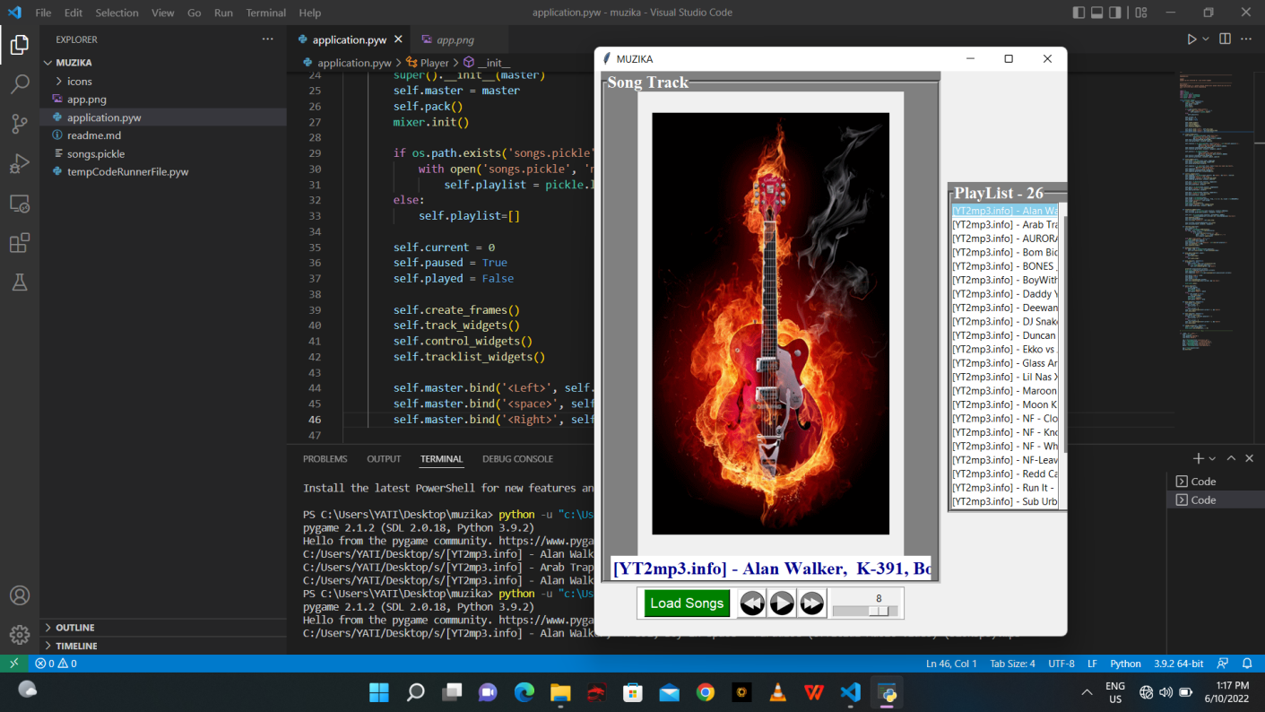

**Fig. 1**

## CHAPTER 5 Advantages/Benefits of Using Python

The diverse application of the Python language is a result of the combination of features which give this language an edge over others. Some of the benefits of programming in Python include:

1. **Presence of Third Party Modules:**

The Python Package Index (PyPI) contains numerous third-party modules that make Python capable of interacting with most of the other languages and platforms.

1. **Extensive Support Libraries:**

Python provides alarge standard library which includes areas like internet protocols, string operations, web services tools and operating system interfaces. Many high use programming tasks have already been scripted into the standard library which reduces length of code to be written significantly.

1. **Open Source and Community Development:**

Python language is developed under an OSI-approved open source license, which makes it free to use and distribute, including for commercial purposes.

Further, its development is driven by the community which collaborates for its code through hosting conferences and mailing lists, and provides for its numerous modules. **4. Learning Ease and Support Available:**

Python offers excellent readability and uncluttered simple-to-learn syntax which helps beginners to utilize this programming language. The code style guidelines, PEP 8, provide a set of rules to facilitate the formatting of code. Additionally, the wide base of users and active developers has resulted in a rich internet resource bank to encourage development and the continued adoption of the language.

1. **User-friendly Data Structures:**

Python has built-in list and dictionary data structures which can be used to construct fast runtime data structures. Further, Python also provides the option of dynamic highlevel data typing which reduces the length of support code that is needed.

1. **Productivity and Speed:**

Python has clean object-oriented design, provides enhanced process control capabilities, and possesses strong integration and text processing capabilities and its own unit testing framework, all of which contribute to the increase in its speed and productivity. Python is considered a viable option for building complex multiprotocol network applications.

As can be seen from the above-mentioned points, [Python offers a number of advantages for software development.](https://www.invensis.net/it-outsourcing-services/outsource-python-application-development-services/?utm_source=invensis-blog&utm_campaign=blog-post&utm_medium=content-link&utm_term=benefits-of-python-over-other-programming-languages) As upgrading of the language continues, its loyalist base could grow as well.

## CHAPTER 6 PRODUCT FEATURES

1. PLAY : We added play option for playing the song which is imported from library of system.

1. STOP : For stoping th rrecently played music.

1. PAUSE : To pause the receently playing music.

1. REPEAT : Repeat the playing music.

1. PLAYLIST : In this we have given option to add songs

From system.

7.ADD : By this option we can add songs.

## REFERENCES

> <https://tkdocs.com/tutorial/styles.html>

> <https://en.wikipedia.org/wiki/Pygame>

> <https://www.geeksforgeeks.org/multithreading-python-set>